|  |  |
| --- | --- |
|  | **FPT ACADEMY INTERNATIONAL**  **FPT – APTECH COMPUTER EDUCATION** |

**Centre Name: ACE-HCMC-2-FPT.**

**Address: 590 Cach Mang Thang 8, District 3, Ho Chi Minh City, Viet Nam.**

**PICNICGAMES**

|  |  |  |
| --- | --- | --- |
| **Supervisor.** | Mr. Nguyen Phat Tai | |
| **Batch.** | T1.2011.M0 | |
| **Group.** | 6 | |
| **Serial No.** | **Enrollment Number** | **Student Name** |
| 1. | Student1287968 | Nguyen Hoang Minh |
| 2. | Student1285592 | Dinh Ngoc Minh Hieu |
| 3. | Student1286085 | Nguyen Tran Hoang Phuc |
| 4. | Student1285593 | Pham Tran Hoang Anh |

Month March Year 2021

**This is to certify that**

**Mr.:**

Nguyen Hoang Minh

Dinh Ngoc Minh Hieu

Nguyen Tran Hoang Phuc

Pham Tran Hoang Anh

**has successfully designed & developed**

eProject: PicnicGames website

**Submitted by: Nguyen Hoang Minh**

**Date of issue: 25-Mar-2021**

**Authorized Signature: Minh**



**TABLE OF CONTENTS**

FPT – APTECH COMPUTER EDUCATION 1

ACKNOWLEGMENT 4

SYNOSIS 4

PROBLEM DEFINITION 4

CUSTOMER'S REQUIREMENTS SPECIFICATIONS (CRS) 5

Business/Project Objective: 5

Hardware/ Software Requirements: 6

SCOPE OF THE WORK (IN BRIEF) 7

Architecture and design of the system 8

Diagram of the website 9

TASK SHEET REVIEW 1 10

# ACKNOWLEGMENT

On behalf of all the members of group 6, I would like to thank you all for the hard works, supports to make this eProject complete successfully. Especially, Mr. Nguyen Phat Tai, our teacher, he helped us a lot from the day that we started to study at FPT Aptech. With this eProject, he has guided us with his enthusiasm and rigorous, because of his guiding, we would be able to finish this project. Besides, I want to thank all the team member of group 6, each of the team members has been working continuously in 4 weeks in order to complete this project. The last but not least, we would like to say thank you to our family for always supporting us, creating the best conditions for us to focus on the project, and putting faith in the dreams we pursue.

# SYNOSIS

We need to create a website that meets all the requirement of our customers, PicnicGames. They need to be introduced to some picnic games. The main purpose of this website is to reach to the customers, who have interest in picnic games.

# PROBLEM DEFINITION

The Web site is to be created based on the following requirements.

1. The Home Page should be created making use of Sections with a suitable logo, the header section can be added which will show images of various creative products.
2. The site must contain the links to navigate through any category for the information.
3. The games should be categorized according to the type of games indoor/outdoor
4. Also there should different be sections for:
   * Kids
   * Males
   * Females
   * Family games
5. When a user selects any particular category, a list of available game options for that particular category will be displayed
6. All details about the selected game to be displayed as material needed, time required, how to play etc with the demo videos / instruction document ,also these should be stored in Individual Word documents which can be downloaded or viewed by the User who wishes to see the same.
7. Along with the games there should also be a section for a common iternery for small getaways with suggested locations.
8. Contact us page: contact us details with location should be displayed using GeoLocation API (eg. GoogleMaps).
9. Navigation should be smooth and images should be clear.

# CUSTOMER'S REQUIREMENTS SPECIFICATIONS (CRS)

**Client: PICNICGAMES**

### Business/Project Objective:

In today’s busy and active world, quality time with family, friends and relatives is often overlooked, but picnics can be helpful in making up for some of this lost time. Spending time together benefits children by providing security, love, and a sense of belonging. Taking time to talk with your children is a great way to connect with them and learn from each other. Regular communication can also give family members chances to plan other fun and engaging activities. Fun games and little competitions are great ways to keep children occupied while engaging with the family. Hence it is thought of developing a website which will provide variety of indoor/outdoor picnic games that can be enjoyed with all.

The website is to be developed for the Windows Platform using HTML5, CSS, JavaScript, Bootstrap, jQuery and Geolocation. The site should work well in all leading browsers including Chrome, IE, Firefox etc.

**Input to the system:**

* + - * Searching products based on type of games.

**Output from the system:**

* A menu that will categorize all the functions of the site.
* Display the list of available albums category wisely.
* Perform the search based on a particular: type of games.
* Site should be able to provide brief introduction/history about my team under About Us page.
* The location of my team's workplace under Contact-Us page.
* Besides the above requirements, the site should have look and feel as per the industry standards.

**Expected delivery date:** 29-March-2021.

**List of deliverables:**

* + - * Document Word.
      * User Guide.
      * Source code.

### 

### Hardware/ Software Requirements:

**Hardware**

* A minimum computer system that will help you access all the tools in the courses is a Pentium 166 or better
* 64 Megabytes of RAM or better

**Software**

* Notepad/HTML editor
* Dreamweaver
* IE 5.0/ Netscape 6.0

# SCOPE OF THE WORK (IN BRIEF)

After a long and detailed discussion, our group has decided to create a website contain the following webpages:

1. ***Home***: Display images about picnic games, an introduction about PicnicGames.
2. ***Indoor Games***: Show all indoor games.
3. ***Outdoor Games***: Show all outdoor games.
4. ***Games For Kids***: show all games for kids.
5. ***Games For Male***: show all games for male.
6. ***Games For Female***: show all games for female.
7. ***Games For Family***: show all games for family.
8. ***About Us***: Display the information about us.
9. ***Contact Us***: Display the address of the company, allow customers to request any information they want from PicnicGames.

# Architecture and design of the system

Webpage request

**JS CODE**

dfdasddf

**CLIENT**

**SERVER**





Requested Page

**RENDERING**

**ENGINE**

**CSS CODE**

**HTML CODE**

**WEB SERVER**

**WEB BROWSER**

**BOOTSTRAP**

**& JQUERY**

dfdasddf

# Diagram of the website

.

HOME

INDOOR GAMES

CONTACT US

ABOUT US

OUTDOOR GAMES

GAMES FOR KIDS

GAMES FOR MALE

GAMES FOR FEMALE

GAMES FOR FAMILY



# TASK SHEET REVIEW 1

|  |  |  |  |  |  |  |  |
| --- | --- | --- | --- | --- | --- | --- | --- |
| **Project Ref. No.:**  **eP/Advertisement Portal Management**  **System/01** | | **Project Title:** | **Activity Plan Prepared By:** | **Date of Preparation of Activity Plan:** | | | |
| **Sr.**  **No.** | **Task** | **Actual**  **Start Date** | **Actual Days** | **Team**  **Mate Names** | **Status** |
| 1 | Problem Statement | PicnicGames | Minh | 3-Mar-21 | 1 | Anh | Completed |
| 2 | Analysis of PicnicGames requirements about the website | 3-Mar-21 | 1 | Hiếu | Completed |
| 3 | The scope of the work (in brief) | 3-Mar-21 | 1 | Phúc | Completed |
| 4 | Architecture and design of the system | 3-Mar-21 | 1 | Hiếu | Completed |
| 5 | Diagram of the website | 3-Mar-21 | 1 | Minh | Completed |
| 6 | Task Sheet | 3-Mar-21 | 1 | Minh | Completed |

|  |  |
| --- | --- |
| **Date:22/3/2021** | |
| Signature of Instructor:  **Mr. Nguyen Phat Tai** | Signature of Team Leader:  **Nguyen Hoang Minh** |

# SITE MAP

INDOOR PAGE

KIDS

CONTACT US PAGE

INDOOR

ABOUT US PAGE

ABOUT US

HOME PAGE

CONTACT US

OURDOOR

OUTDOOR PAGE

KIDS PAGE

MALE PAGE

FEMALE PAGE

FAMILY PAGE

FAMILY

FEMALE

MALE

# MOCK OF THE WEBSITE

1. **Homepage**

HEADER

BENEFIT OF PLAY

GAMES LIST

BLOGS

FOOTER

1. **ABOUT US**

HEADER

About My Team

FOOTER

1. **CONTACT US**

HEADER

CONTACT

MAP

ADDRESS

FOOTER

1. **Indoor/Outdoor Games.**

HEADER

INTRODUCE INDOOR/OUTDOOR

IMAGE ALBUM

ALL GAMES INDOOR/OUTDOOR

GAME LIST

FOOTER

**5. Game for kids/ male/ female/ family.**

HEADER

INDOOR GAMES

OUTDOOR GAMES

DOWNLOAD FILE WORD

FOOTER

# 

# TASK SHEET REVIEW 2

|  |  |  |  |  |  |  |  |
| --- | --- | --- | --- | --- | --- | --- | --- |
| **Project Ref. No.:**  **eP/Advertisement**  **Portal Management System/01** | | **Project Title:** | **Activity Plan Prepared By:** | **Date of Preparation of Activity Plan:** | | | |
| **Sr.**  **No.** | **Task** | **Actual Start Date** | **Actual Days** | **Team Mate Names** | **Status** |
| 1 | Site map | PicnicGames | Minh | 10-Mar-21 | 1 | Hiếu | Completed |
| 2 | Mock of the website | 10-Mar-21 | 1 | Anh | Completed |
| 3 | Task sheet | 10-Mar-21 | 1 | Phúc | Completed |

|  |  |
| --- | --- |
| **Date:22/3/2021** | |
| Signature of Instructor:  **Mr. Nguyen Phat Tai** | Signature of Team Leader:  **Mr. Nguyen Hoang Minh** |

# WEBSITE DESCRIPTION

1. **Home Page**

* Description

Home page displays following information:

* Introduce PicnicGames Page.
* Benefit of Play.
* Game List.
* Blogs.
* Screenshot

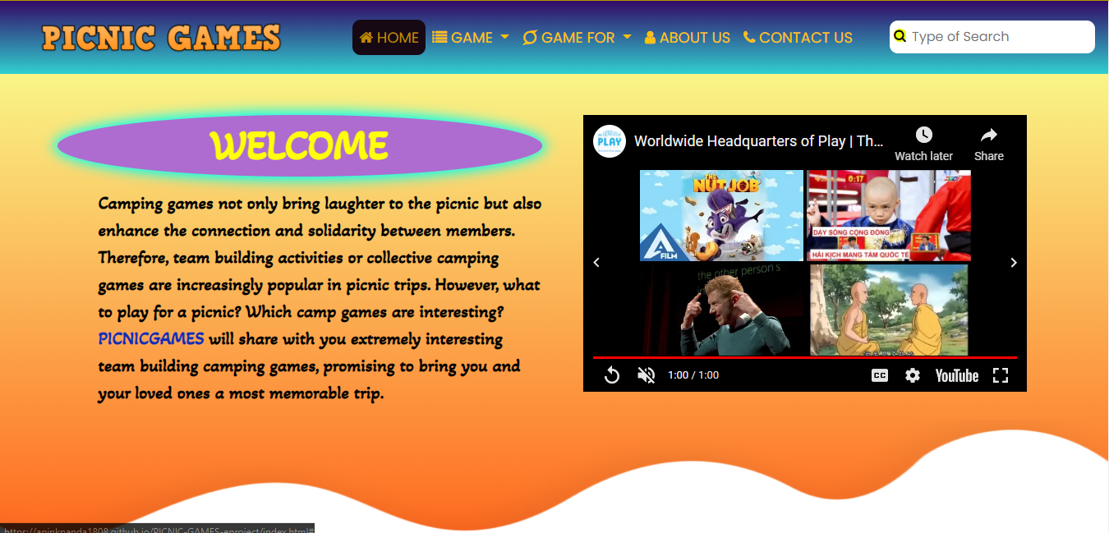

Benefit of play.

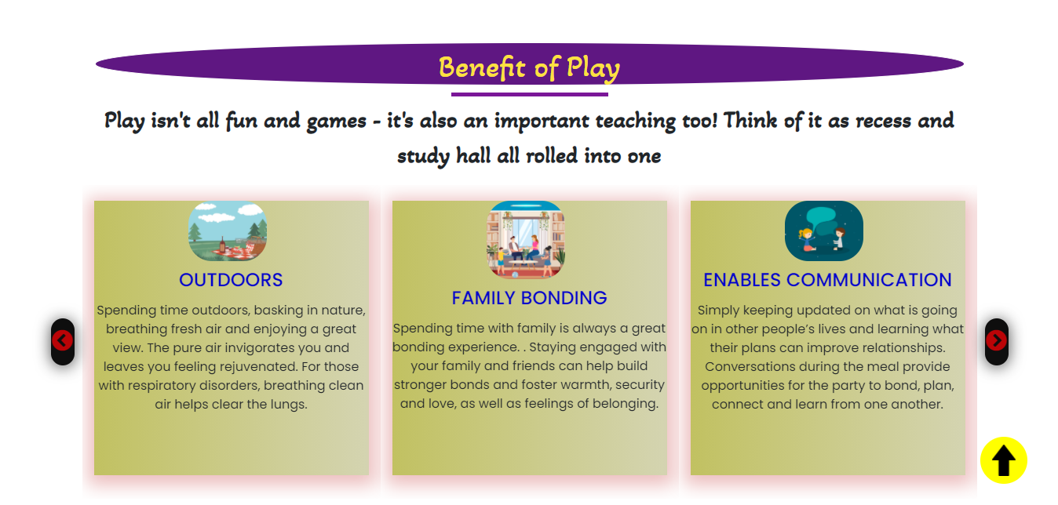

Game List

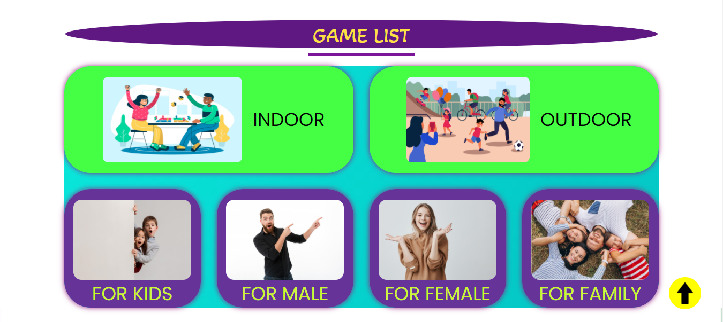

Blogs

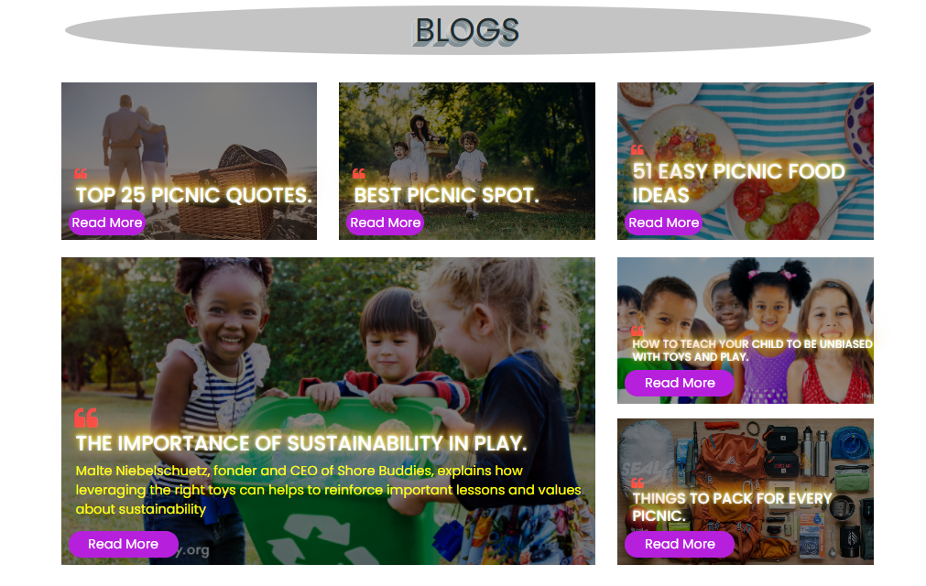

1. **About us**

* Description

This page displays information about PicnicGames, our images that we provide and our team member.

* Screen shot

1. **Contact us:**

* Description

This page displays contact information: location, telephone number, email and a quick contact form for customer.

* Screen shot

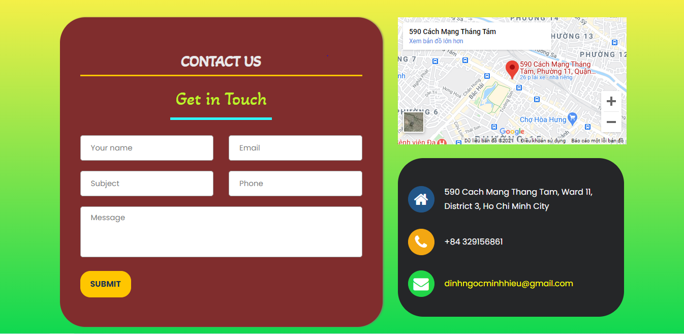

1. **Game & Game For:**

* Description:
* This page displays following information:
* All games are displayed at PicnicGames (Games for Kids, Games for Male, Games for Female, Games for Family), when click on 1 specific item, it will show the detail of that item.
* Menu filter and search window to easily find items based on categories.
* Screen shot



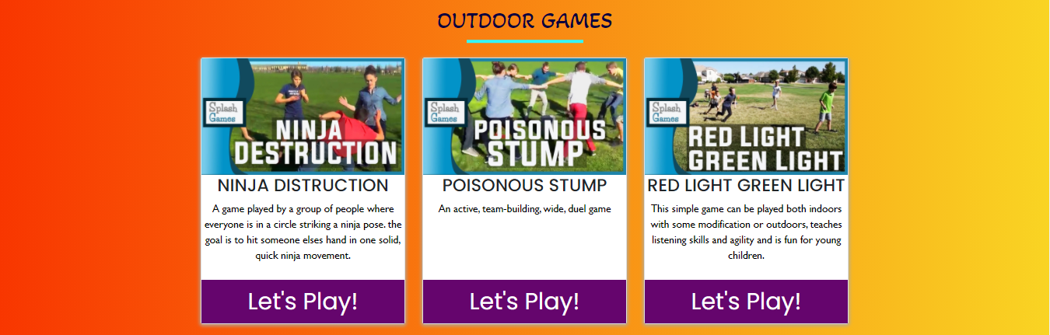

Details game:

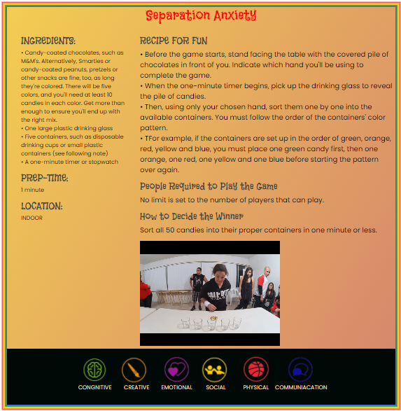

**HTML, CSS, JAVASCRIPT DESCRIPTION**

**This html to create the header for the home page:**

**This css to create style for the title:**

**This script to create slideshow for the game catalog:**

**This scripts is used to program the return top button:**

# TASK SHEET REVIEW 3

|  |  |  |  |  |  |  |  |
| --- | --- | --- | --- | --- | --- | --- | --- |
| ***Project Ref. No.:***  ***eP/Advertisement Portal Management System/01*** | | ***Project Title:*** | ***Activity Plan Prepared By:*** | ***Date of Preparation of Activity Plan:*** | | | |
| ***Sr.***  ***No.*** | ***Task*** | ***Actual Start***  ***Date*** | ***Actual Days*** | ***Team Mate***  ***Names*** | ***Status*** |
| *1* | *Home page (navigation bar)* | ***Picnic***  ***Games*** | ***Minh*** | 17-Mar-21 | *1* | *Hieu* | *Completed* |
| *2* | *Contact Us* | 17-Mar-21 | *1* | *Anh* | *Completed* |
| *3* | *About us* | 17-Mar-21 | *1* | *Phuc* | *Completed* |
| *4* | *Games* | 17-Mar-21 | *1* | *Hieu* | *Completed* |
| *5* | *Feedback* | 17-Mar-21 | *1* | *Minh* | *Completed* |
| *6* | *Sitemap* | 17-Mar-21 | *1* | *Anh* | *Completed* |
| *7* | *Javascript for slick* |  |  | 17-Mar-21 | *1* | *Hieu* | *Completed* |
| *8* | *Javascript for return top button* |  |  | 17-Mar-21 | *1* | *Hieu* | *Completed* |

|  |  |
| --- | --- |
| **Date: 25/3/2021** | |
| Signature of Instructor:  **Mr. Nguyen Phat Tai** | Signature of Team Leader:  **Mr. Nguyen Hoang Minh** |